| **NAME:** | **LASHYA P** |
| --- | --- |
| **ROLL NO:** | **18BCS045** |
| **COURSE:** | **INTERNET AND WEB PROGRAMMING** |
| **CODE:** | **U18CSI6201** |
| **DATE:** | **06.12.2021** |

**EXPERIMENT -8**

**AIM:**

Develop a servlet program to add two numbers.

**PROCEDURE:**

1. To create a form in HTML we need to use the following tags:
   * 1. <form>: to create a form to add fields in its body.
     2. <input>, <select>, <textarea>…: to create form fields like text boxes, dropdown list, text area, check boxes, radio buttons,… and submit button.
2. To make the form works with Java servlet, we need to specify the following attributes for the <form> tag:
   * 1. method=”post”: to send the form data as an HTTP POST request to the server. Generally, form submission should be done in HTTP POST method.
     2. action=”*URL of the servlet*”: specifies relative URL of the servlet which is responsible for handling data posted from this form.
3. On the server side, we need to create a Java servlet which is mapped to the URL: *addservelt*, as specified in the form’s action attribute.
4. When the input of two number is taken from the user the addition is performed in the servlet

**SOURCE CODE :**

**Newfile.html:**

<!DOCTYPE html>

<html>

<head>

<meta charset="ISO-8859-1">

<title>Insert title here</title>

</head>

<body>

<form action="addServelet" method="get" align="center">

Enter first number:<input type="text" name="num1" align="center"><br>

Enter second number:<input type="text" name="num2" align="center"><br>

<input type="submit" value="ADD" align="center">

</form>

</body>

</html>

**Addservlet:**

import java.io.IOException;

import java.io.PrintWriter;

import javax.servlet.ServletException;

import javax.servlet.annotation.WebServlet;

import javax.servlet.http.HttpServlet;

import javax.servlet.http.HttpServletRequest;

import javax.servlet.http.HttpServletResponse;

@WebServlet("/addServelet")

public class addServelet extends HttpServlet {

private static final long serialVersionUID = 1L;

public addServelet() {

super();

// TODO Auto-generated constructor stub

}

protected void doGet(HttpServletRequest request, HttpServletResponse response)

throws ServletException, IOException

{

PrintWriter pw = response.getWriter();

int number1 = Integer.parseInt(request.getParameter("num1"));

int number2 = Integer.parseInt(request.getParameter("num2"));

int sum = number1 + number2;

pw.println("sum of the given two numbers is : "+sum);

}

}

**OUTPUT:**

**GETTING INPUT FROM CLIENT-SIDE:**

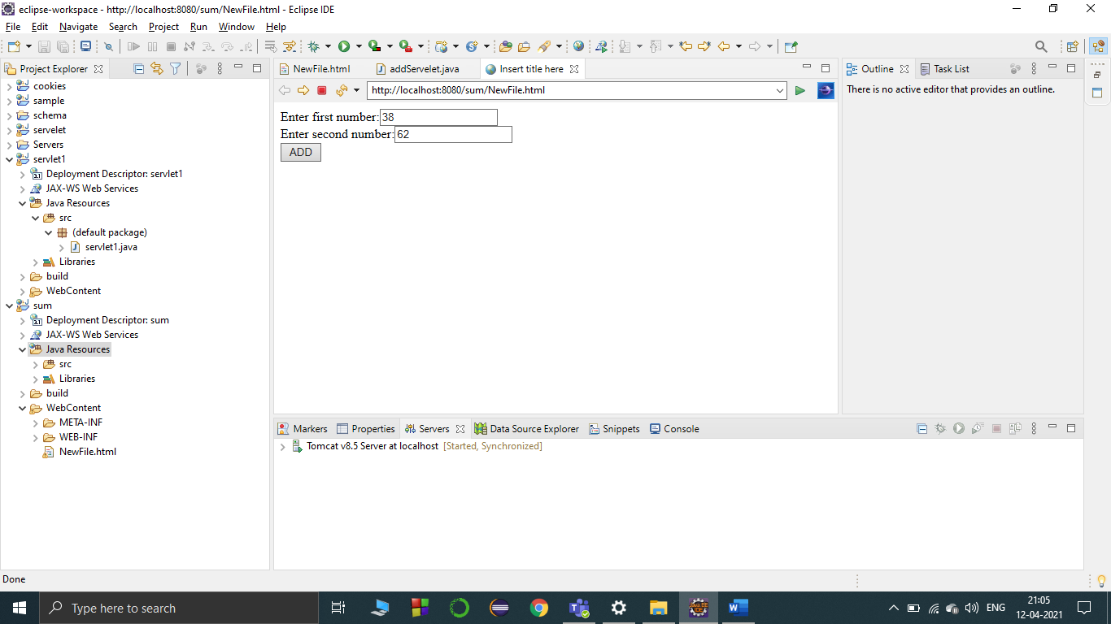

**AFTER ADDING THE NUMBERS IN THE SERVELET OUTPUT IS DISPLAYED**

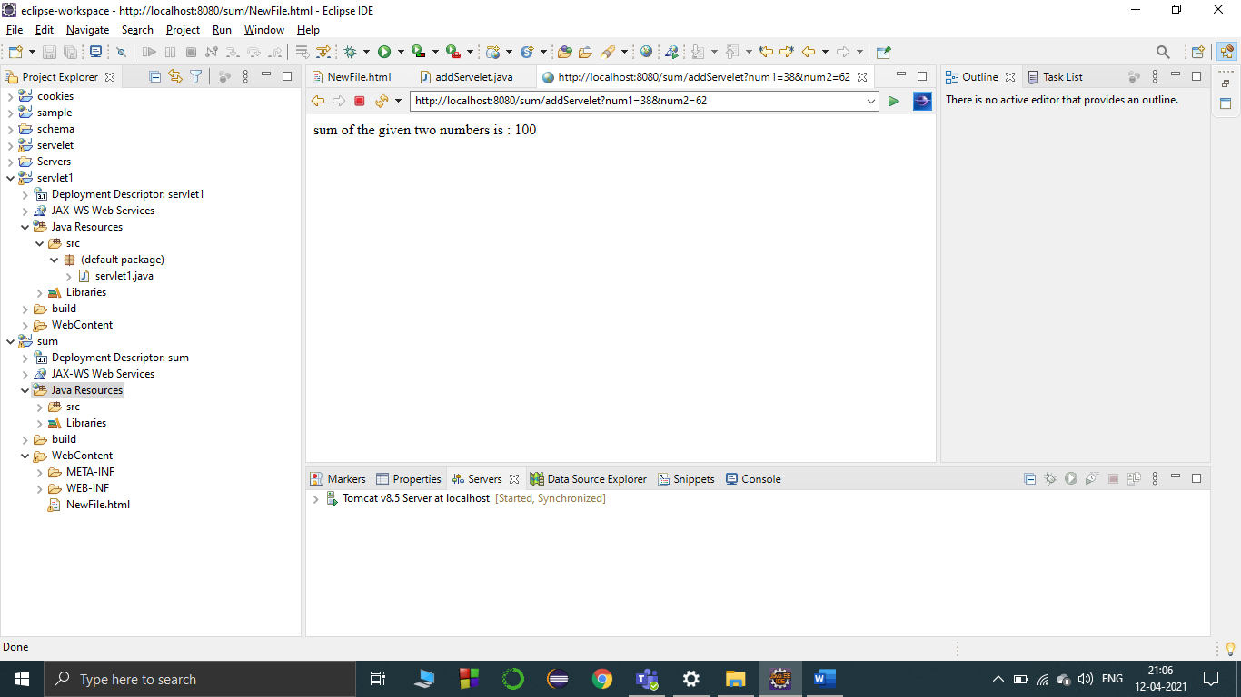

**RESULT :**

The servlet program to add two numbers is developed.